

Software Engineering Department  
ORT Braude College

Capstone Project Phase A – 61998

**MedCall**

24-1-D-10 

Supervisor: Mr. Alex Keselman  
  
Tareez Ghandour - 211515838 | Email: Tareez.Ghandour@e.braude.ac.il

Leen Hawa - 314655309 | Email:  Leen.Hawa@e.braude.ac.il

GIT Link:<https://github.com/tareezgh/MedCall>

**Abstract**

Our MedCall project is an online platform that aims to transform emergency medical services (EMS) by implementing modern technology and algorithms to speed up response times. It enables real-time communication between people in need of help and medical services. Our system uses the Nearest Neighbor algorithm to quickly locate and track the nearest ambulance. Users can see in real-time the location of the ambulance; this feature ensures that all parties involved can monitor the ambulance's progress and estimated time of arrival. MedCall is designed to be user-friendly and easy to use, making it accessible to all users. Our goal is to significantly improve the speed and reliability of medical interventions in emergencies, helping to save lives and enhance patient outcomes.

*Table of Contents*

1. Introduction 4

2. Background and Related Work 5

*2.1 Related Work* 5

*2.2 Algorithms* 6

3. Expected Achievements 7

*3.1 Outcomes* 7

*3.2 Unique Features* 7

*3.3 Criteria for Success* 8

4. The Process 9

*4.1 Research – Emergency Medical Service (EMS)* 9

*4.2 Methodology and Development Process* 9

*4.3 Challenges and Constraints* 10

5. Product 11

*5.1 Requirements* 11

*5.2 Architecture overview* 12

*5.3 Diagrams* 12

*5.3.1 Use-Case* 12

*5.3.2 Class Diagram* 13

*5.3.3 Activity Diagram* 14

*5.4 UI Characterization* 15

*5.4.2 Registration, Login and Reset password* 18

*5.4.3 User Dashboard* 22

*5.4.4 Driver Dashboard* 26

*5.4.5 Dispatch Center Dashboard* 28

6. Verification and Evaluation 31

*5.1 Evaluation* 31

*5.2 Verification* 31

7. References 34

# **Introduction**

Emergency medical services are of great importance in any community, playing a crucial role in keeping public safety and health. They offer a wide range of public services responsible for providing immediate assistance and support during life-threatening situations, like accidents, natural disasters, fires and many more incidents that require a skilled response. First responders often face challenges in reaching individuals quickly, especially in remote areas or during times of heavy traffic. This problem prevents people from getting the proper treatment within the required time.

Nowadays, people must make a phone call to get emergency care, yet the process of calling an ambulance usually involves several crucial stages. It begins with the recognition of a medical emergency, where individuals evaluate the severity of the situation. Once recognizing the need for urgent medical attention, the first stage involves immediately dialing the emergency number, to connect with the dispatch center. During the call, the dispatcher gathers essential information about the nature of the emergency, the location, and the condition of the patient. In the second stage, emergency services are sent to the location, while the dispatcher may provide pre-arrival instructions to the caller, guiding them on basic first aid actions. The third stage involves the arrival of the ambulance at the location where trained paramedics assess the patient and provide help.

The current emergency care scenario has several flaws. Making a phone call may present challenges in recognizing medical emergencies. Communication challenges such as language barriers, unclear descriptions, or the caller's emotional state may set back effective communication. In addition, the entire emergency response system relies on a functional and reliable telecommunications network. Areas with poor connectivity may face challenges in reaching emergency services promptly. Furthermore, answering an emergency phone call and processing information about a critical situation can be highly stressful for the phone operator. This psychological impact may affect their ability to think and communicate clearly.

Our project aims to significantly reduce emergency response times, by offering a user-friendly platform that connects people with the dispatch center in real-time, our platform locates the nearest ambulance to the patient's location, providing crucial assistance choosing the proper ambulance for specific situations. The technology we will use ensures that both sides benefit from this solution, the dispatch centers gain access to real-time patient location and status information, enabling them to allocate appropriate resources efficiently. Meanwhile, individuals can track the ambulance's location in real-time and receive pre-arrival instructions to help the patient if needed, this will save time and effort for both individuals and the emergency services.  
Patients, ambulance drivers, and the public who depend on this information are among the project's stakeholders. Patients receive timely medical attention, while ambulance drivers and paramedics will be better equipped to respond to emergencies swiftly and provide critical care to those in need. By enhancing the speed and effectiveness of emergency response efforts, the solution directly addresses the needs and concerns of these stakeholders.

# **Background and Related Work**

## ***2.1 Related Work***

Before we dive into our project, let us look at what others have done in emergency medical services (EMS). Learning from existing ideas can help us make our solution better.

* **MyMDA App**: Magen David Adom offers the MyMDA mobile application, which allows individuals to request emergency medical assistance from their smartphones. The MyMDA app streamlines the process of initiating emergency calls and transmitting location data to responders.
* **United Hatzalah:** In Israel, United Hatzalah uses smart technology to send volunteer medics quickly to emergencies. They track medics using GPS and communicate in real-time, making sure help gets to people fast, especially in busy cities.

These examples show how technology and smart thinking can make EMS better. By looking at what others have done, we can get ideas to make our project even more helpful for people in emergencies.

## ***2.2 Algorithms***

* **Nearest Neighbor Algorithm** [2]

With life and death situations time is an extremely important factor. The Nearest Neighbor algorithm is essential for the emergency response platform as it plays a crucial role in minimizing response times and optimizing resource allocation. The algorithm ensures swift medical assistance by efficiently finding the nearest available ambulance to an emergency location. The algorithm's simplicity and fast computation further contribute to quick decision-making, crucial in emergency situations where time is crucial.

* **Real-time algorithms** [3]

Real-time algorithms help update decision making based on constantly changing data and circumstances, by analyzing incoming information, like traffic and the availability of medical assistance. These algorithms help in optimizing response strategies in real-time, so emergency teams can navigate through obstacles efficiently.

* **Geolocation and Mapping Algorithm**

Numerous geolocation technologies can pinpoint a person's or and object's position on the Earth [4]. The algorithms are responsible for determining the geographical location of an object or user based on various data sources such as GPS signals. These algorithms help in optimizing arrival and response time, in addition to accurate location tracking.

* **Machine Learning Live Chat Support**

Live chat support has emerged as a powerful solution for bridging the gap between businesses and customers in the digital era. Its ability to provide prompt assistance and personalized interactions that yield higher customer satisfaction rates has turned it into an essential tool for businesses across various industries [5].

To utilize machine learning for live chat support using Natural Language Processing (NLP) techniques to analyze and understand the intent and context behind each inquiry to generate appropriate and timely responses. And to generate appropriate responses to customer queries. The system is trained to recognize various intents and maintain context throughout the conversation, ensuring accurate and context-aware responses. Additionally, the system's capabilities extend to assisting in selecting the appropriate ambulance type based on the emergency.

# **Expected Achievements**

## ***3.1 Outcomes***

The outcome we expect to achieve in this project is to develop a comprehensive platform for emergency call services that efficiently locates the nearest ambulance to the accident location, considering availability and type. Our platform will offer a range of features to make the emergency call more easily and efficiently, including real-time ambulance tracking capabilities.

We aim to significantly reduce emergency response times, ultimately saving lives and improving outcomes for individuals in critical situations.

## ***3.2 Unique Features***

* **Finding the Nearest Ambulance:** One of the primary and unique features of our platform is the utilization of the Nearest Neighbor Algorithm to determine the nearest available ambulance to the site of an emergency. This functionality ensures swift response times and optimal allocation of resources during critical situations. One challenge in this field lies in the implementation of the algorithm to ensure its seamless integration into our platform.
* **Geolocation Services:** Our platform relies on Geolocation Services, which require compatible devices equipped with GPS technology to accurately determine the locations of emergencies and ambulance units in real-time. This technology streamlines coordination between dispatch centers and responders, ensuring efficient response efforts. One challenge is ensuring that all devices used in our system are equipped with GPS functionality for reliable geolocation services.
* **Emergency Response Dashboard:** feature that offers dispatch centers and responders a clear overview of ongoing emergencies, ambulance statuses, and response activities. With real-time updates, a challenge is ensuring the dashboard's simplicity and ease of use.
* **Real-Time Communication:** Our platform provides real-time communication via chat, ensuring immediate interaction and information exchange among dispatch centers, responders, and other stakeholders involved in emergency situations. This feature enables quick collaboration and timely decision-making, essential for effective emergency response.
* **User Authentication:** Our platform includes user authentication and profile management, catering to various user roles such as responders, dispatch centers, and individuals. This feature ensures secure access while allowing users to customize their profiles.
* **Emergency Alert System:** Our platform integrates an alert system that provides timely notifications and updates to dispatch centers, responders, and individuals involved in emergencies. These alerts enable rapid communication, coordination, and response to evolving incidents, ensuring efficient emergency handling.

## ***3.3 Criteria for Success***

The success criteria for the project revolves around reducing emergency response times and improving the overall efficiency of the emergency medical services system. The primary goal is to offer a user-friendly platform that connects individuals with the dispatch center in real-time, providing immediate assistance during critical situations. Success relies on the platform's ability to significantly decrease response times by locating the nearest ambulance to the patient's location and facilitating effective communication between the dispatch center and individuals in need. The project's effectiveness is measured by its ability to provide timely medical care to patients, enhance the efficiency of ambulance drivers and paramedics in responding swiftly, meeting the needs and concerns of the stakeholders involved.

# **The Process**

## *4.1 Research – Emergency Medical Service (EMS)*

With regards to expand our understanding of EMS we focused on answering the following questions:

* What are the primary challenges in the current emergency response system?
* How does the process of calling an ambulance work in the current system, and what are the potential drawbacks?
* What are the potential consequences of delays in emergency response times?
* Who are the stakeholders involved in the project, and what are their respective needs and concerns?
* What potential ethical considerations should be considered when developing and deploying an emergency response platform?

To answer these questions and expand our knowledge, we read articles, watched videos and met up to discuss our thoughts and share our ideas and the main points we should focus on developing our website. Some of the conclusions we reached while researching EMS with regards to developing our idea, there exists a need to add a questionnaire after using our website, this will help us validate our website and improve it. Some of the questions may be:

* Was it easy or difficult to use the website?
* How would you rate the efficiency of the website?
* How satisfied are you with the website and its services?
* What additional features would you like to see in the future?

If we find a connection between the questionnaire and our final analysis, it will confirm the validity of our emergency medical services website.

## *4.2 Methodology and Development Process*

In crafting our project, we have adopted an agile methodology, recognizing its suitability to the dynamic needs of our MedCall platform. Agile methodology enables us to break down the project into manageable increments, known as sprints, each focusing on delivering specific features or functionalities. By prioritizing user stories and features based on their importance and value, we ensure that the development process remains responsive to evolving requirements.

For the development we have decided to use the MERN stack, which comprises MongoDB, Express.js, React.js, and Node.js.

MongoDB handles our data storage needs, Express.js simplifies backend development, React.js creates dynamic user interfaces, and Node.js powers our server-side operations.

The MERN stack offers a robust and flexible foundation for building modern web applications, providing scalability, performance, and ease of development.

Our development process involves two main phases. We start with planning and preparation, where we define project objectives, identify user stories and requirements, develop diagrams, and create a roadmap for development. Then, we move to the implementation stage, where development activities take place. During this stage, we follow an iterative development approach, continuously integrating feedback from stakeholders and conducting regular testing to identify and address issues early in the development process.

## *4.3 Challenges and Constraints*

Looking ahead, one of the significant challenges we anticipate in the project's life cycle involves acquiring the requisite development skills essential for building the website and implementing complex algorithms to locate the nearest ambulances and determine their availability. Developing a comprehensive emergency medical services platform requires proficiency in diverse programming languages and algorithms, which may currently be unfamiliar to us.

To overcome this challenge, we plan to invest time and resources in continuous learning and skill enhancement. This will entail participating in courses and leveraging online resources to deepen our understanding and proficiency in the relevant programming languages and algorithms. By dedicating ourselves to ongoing education and professional development, we aim to overcome these obstacles and deliver a high-quality emergency medical services platform that meets the needs of our users and stakeholders.

# **Product**

## *5.1 Requirements*

**Functional:**

|  |  |
| --- | --- |
| ***Number*** | ***Requirements*** |
| 1 | The system allows user registration via email and password |
| 2 | The system allows user registration via Google authentication |
| 3 | The system allows users to reset forgotten passwords |
| 4 | The system allows grant appropriate permissions based on user roles |
| 5 | The system allows user to initiate emergency calls |
| 6 | The system allows prompt users to provide necessary information |
| 7 | The system allows notifying dispatch centers about the ambulance’s request |
| 8 | The system allows dispatch centers to select appropriate ambulance type |
| 9 | The system allows notifying the nearest available ambulance drivers of incoming emergency calls |
| 10 | The system allows displaying essential information about assigned emergency |
| 11 | The system allows ambulance drivers to accept or decline emergency calls |
| 12 | The system allows communication via chat between individuals and drivers |
| 13 | The system allows providing real-time updates to users |
| 14 | The system allows confirming ambulance arrival and completion of the request |

**Non-Functional:**

|  |  |
| --- | --- |
| ***Number*** | ***Requirements*** |
| 1 | The platform should be user friendly and easy to use |
| 2 | The platform should be handling large amounts of traffic at the same time |
| 3 | The platform must keep user data secure and protected |
| 4 | The platform should support multiple languages |
| 5 | The registration via unique email |
| 6 | The user roles are dispatch center, ambulance drivers and individuals |
| 7 | The information for each emergency is the patients' status and location |
| 8 | The ambulance types are regular and intensive care (ICU) |

## *5.2 Architecture overview*

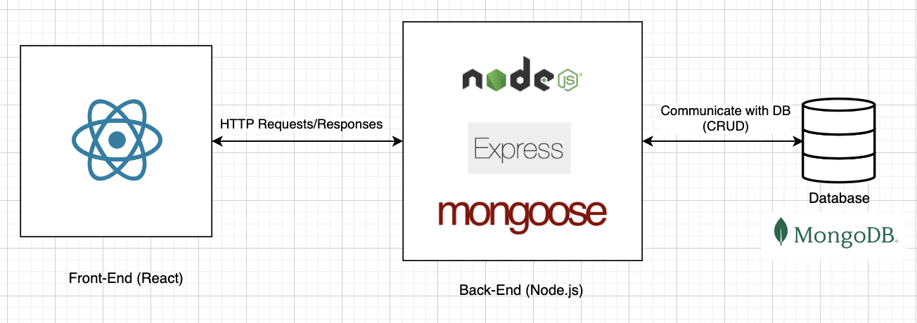

Figure 1 - Architecture scheme.

## *5.3 Diagrams*

### *5.3.1 Use-Case*

Figure 2 - Use case Diagram.

### *5.3.2 Class Diagram*

Figure 3 - Class Diagram

### *5.3.3 Activity Diagram*

Figure 4 - Activity Diagram

## *5.4 UI Characterization*

*5.4.1 Home Page and Request Ambulance*

Figure 5- Home Page

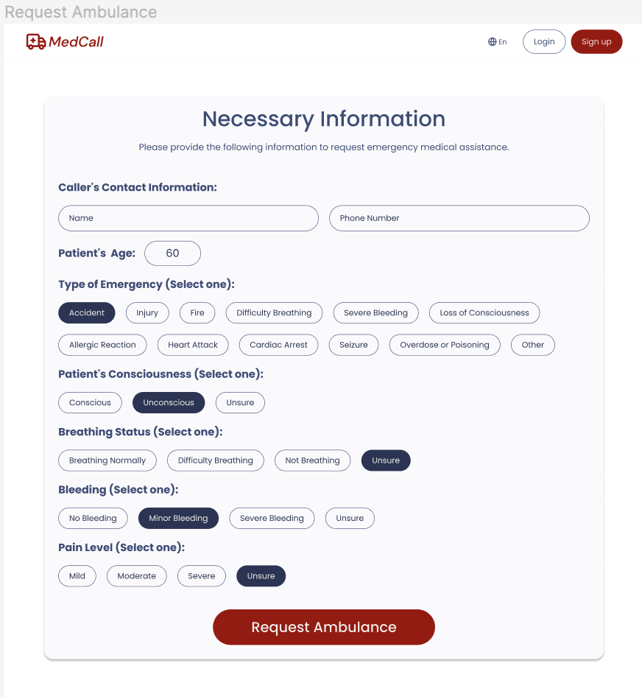The main screen of MedCall, which the user will see, features a simple layout designed to help the user quickly access emergency help. At the top, there are buttons to sign up or log in, each leading to a specific screen. In the first section, there's a call-to-action (CTA) button to request an ambulance fast leading to the next screen. Below that, there's a section explaining how MedCall works, so users know what to expect when they use our platform.

Figure 6 - Request Ambulance Necessary Information

After clicking on the call-to-action (CTA) button, users are directed to “Request Ambulance” screen where they can input necessary information about the emergency. This screen is designed to make it easy for users to provide details by selecting predefined answers to questions. Users will be guided through a series of questions, such as the type of emergency, patient’s status, and any additional information. Each question will have options for users to choose from, simplifying the process of conveying critical details to dispatch centers.

Figure 7 - Request Ambulance Optional Information

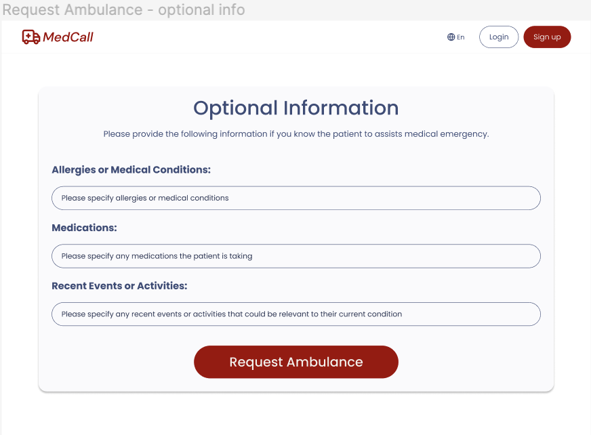

After answering the predefined questions, users reach an optional input screen. Here, they can provide extra details not covered before. Users can type their responses directly. After submission, they're directed to their dashboard. If not logged in, they'll see the guest dashboard.

### *5.4.2 Registration, Login and Reset password*

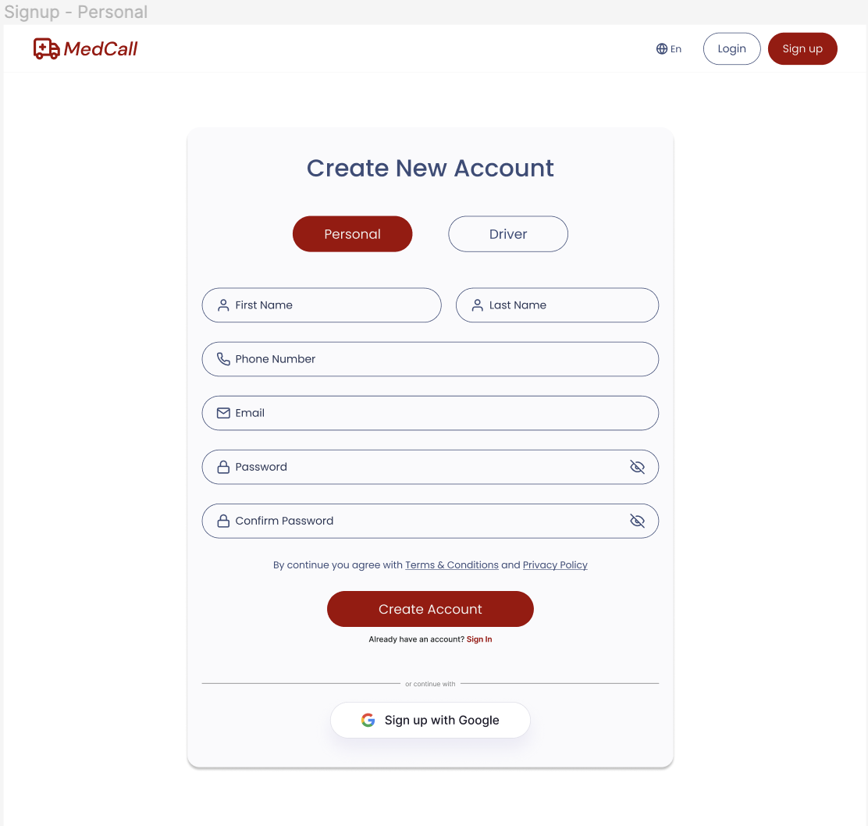

Figure 8 - Sign up

The signup screen allows users to create a new account. Users can choose between a personal or driver account by clicking on tabs. For personal accounts, they need to fill in basic details like name, phone, email, and password. Additionally, users have the option to sign up using their Google account.

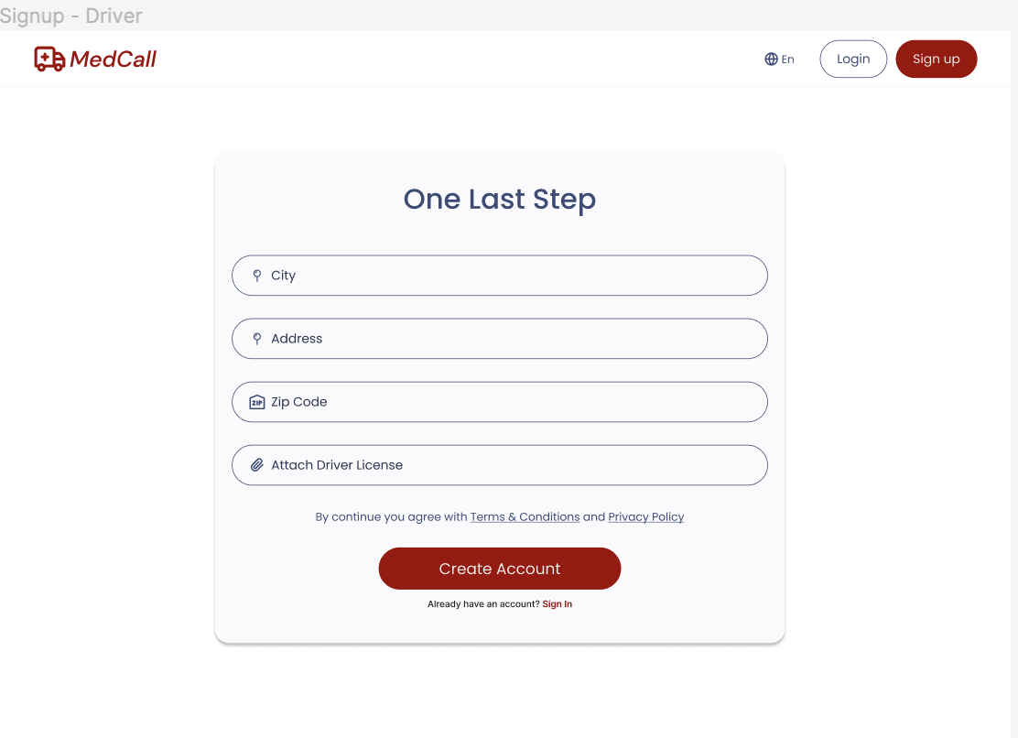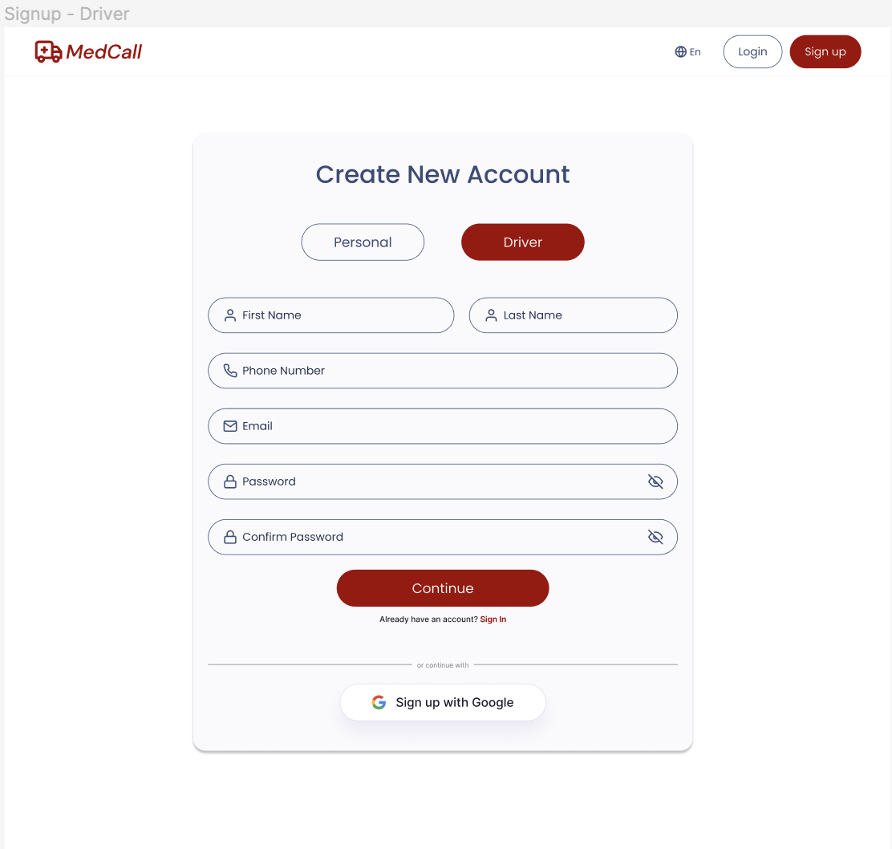

Figure 9 - Sign up Driver More Info

Figure 10 - Sign up Driver

The driver signup screen allows drivers to create a new account. They need to fill in basic details. Driver accounts require additional details on the next screen, like city, address, zip code and to attach ambulance driver license. Additionally, drivers have the option to sign up using their Google account.

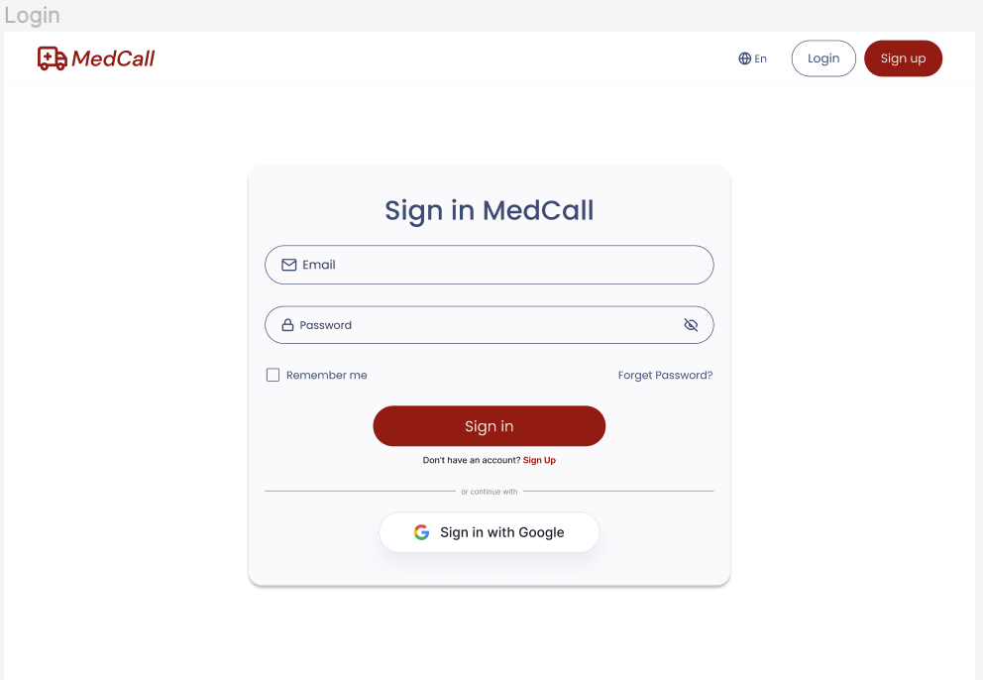

Figure 11 - Login Screen

The login screen is where users log in if they already have an account. Simply enter email and password to access the account. Upon successful login, the user will be directed to respective dashboard tailored to their role. Additionally, users have the option to log in using their Google account.

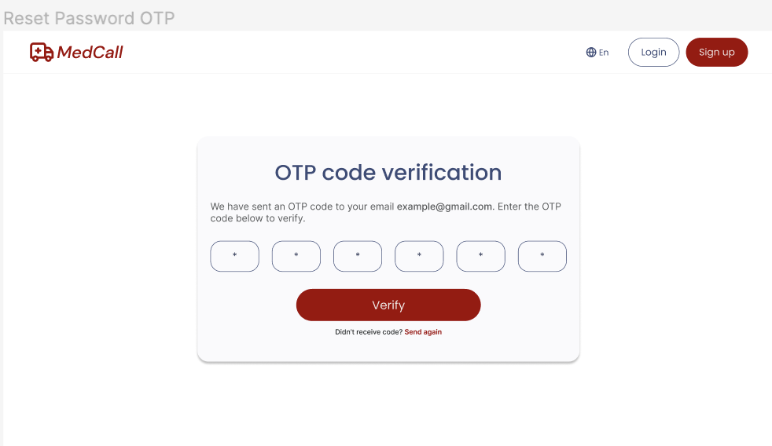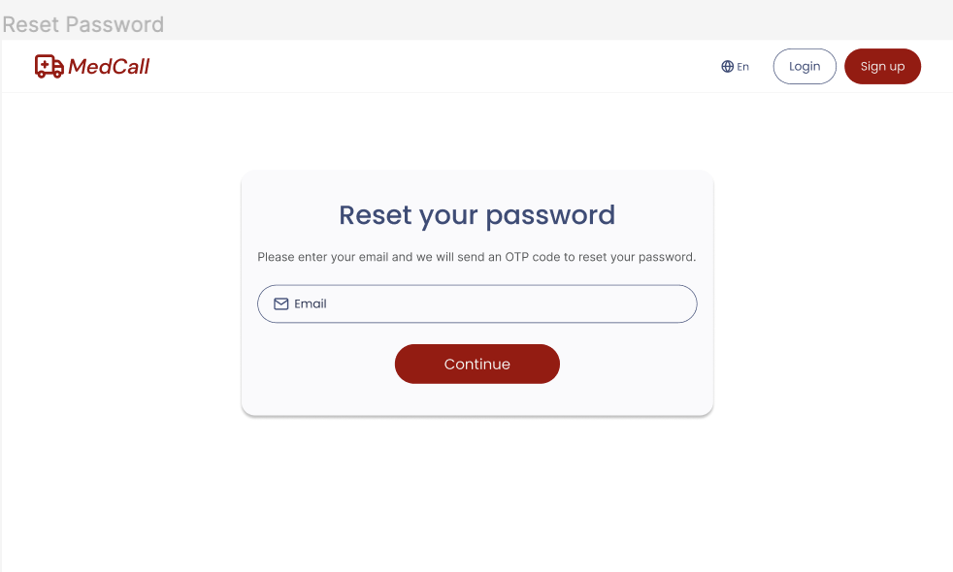The reset password process consists of three screens. Firstly, users begin by entering their registered email address on the email input screen. Once submitted, users receive an OTP (One-Time Password) sent to their email for verification on the OTP verification screen. After confirming the OTP, users proceed to the new password screen where they can input and confirm their new password. This streamlined process ensures that users can easily reset their password in just a few simple steps.

Figure 12 - OTP Screen

Figure 13 - Reset Password

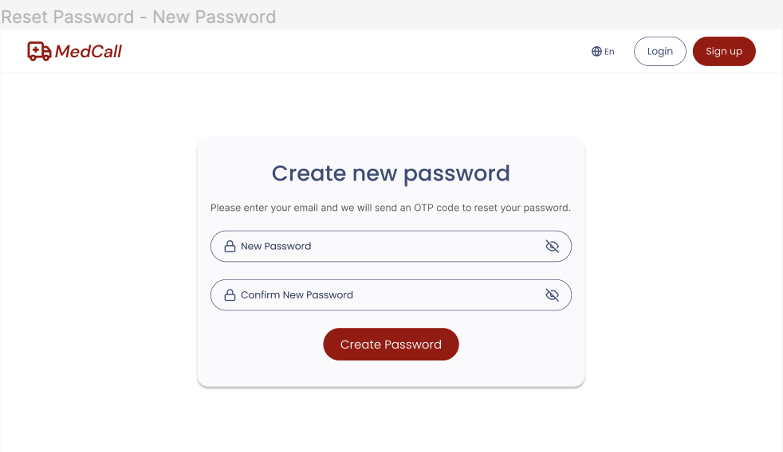

Figure 14 - Create New Password Screen

### *5.4.3 User Dashboard*

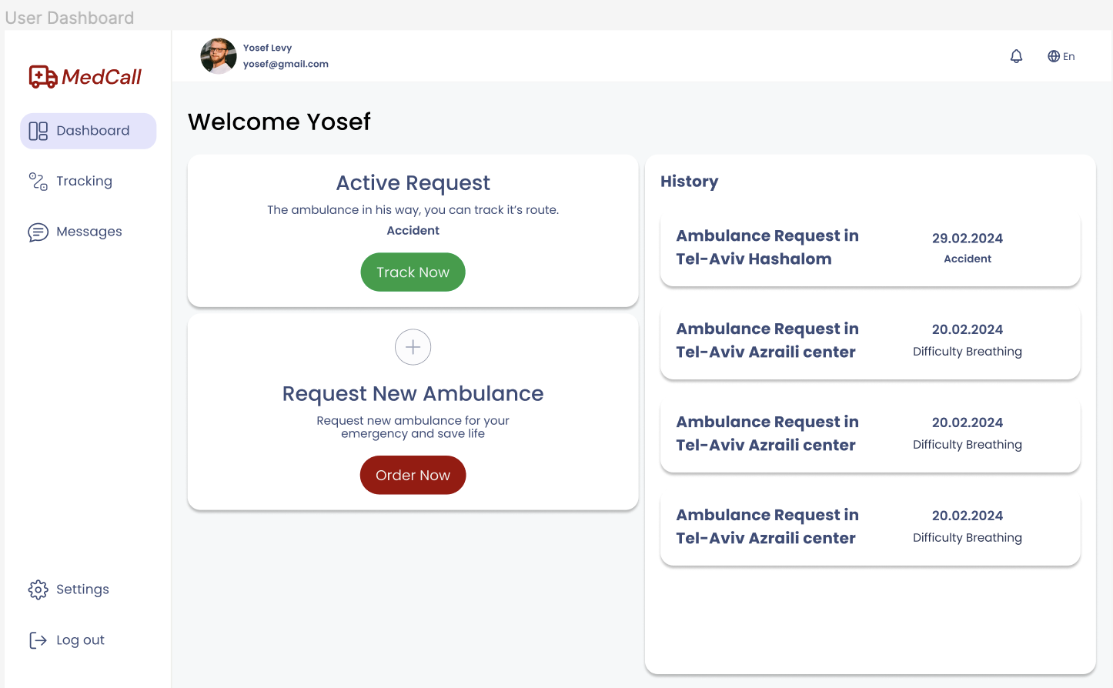

Figure 15 - User Dashboard

The user dashboard screen serves for managing account activities, a sidebar menu allows users to navigate between different sections, including tracking, messages, and settings.   
Users can easily track ongoing emergencies, view messages, make a new request, and adjust account settings. When the user makes a new request, the status will be marked as “Pending” until the nearest driver accepts it. Once accepted, the user can track the status of their request in real-time. At the top users can view notifications to stay informed about important updates, and to change the language of the platform. Additionally, users have the option to log out from their account.

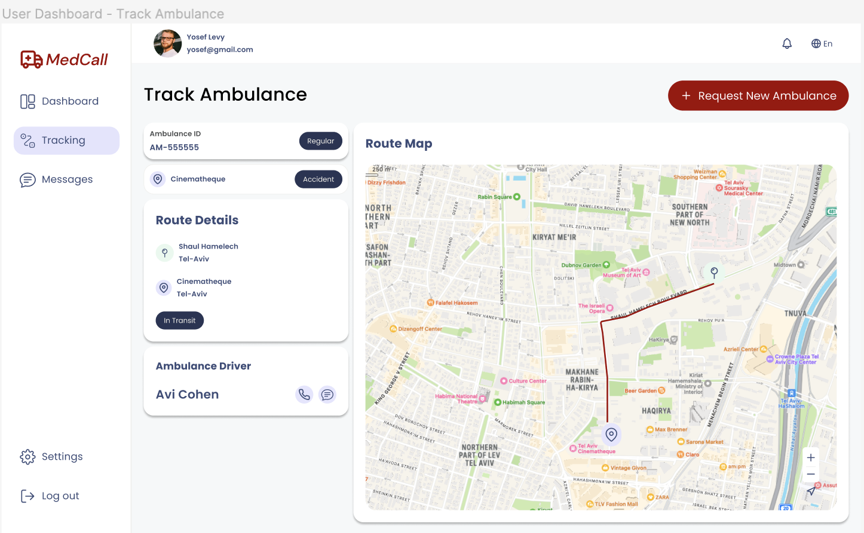

Figure 16 - Track Ambulance Screen

The track screen allows users to monitor the real-time location of the ambulance as it responds to their request. The ambulance and the ambulance’s driver details are also shown.

There is a CTA button to request a new ambulance.

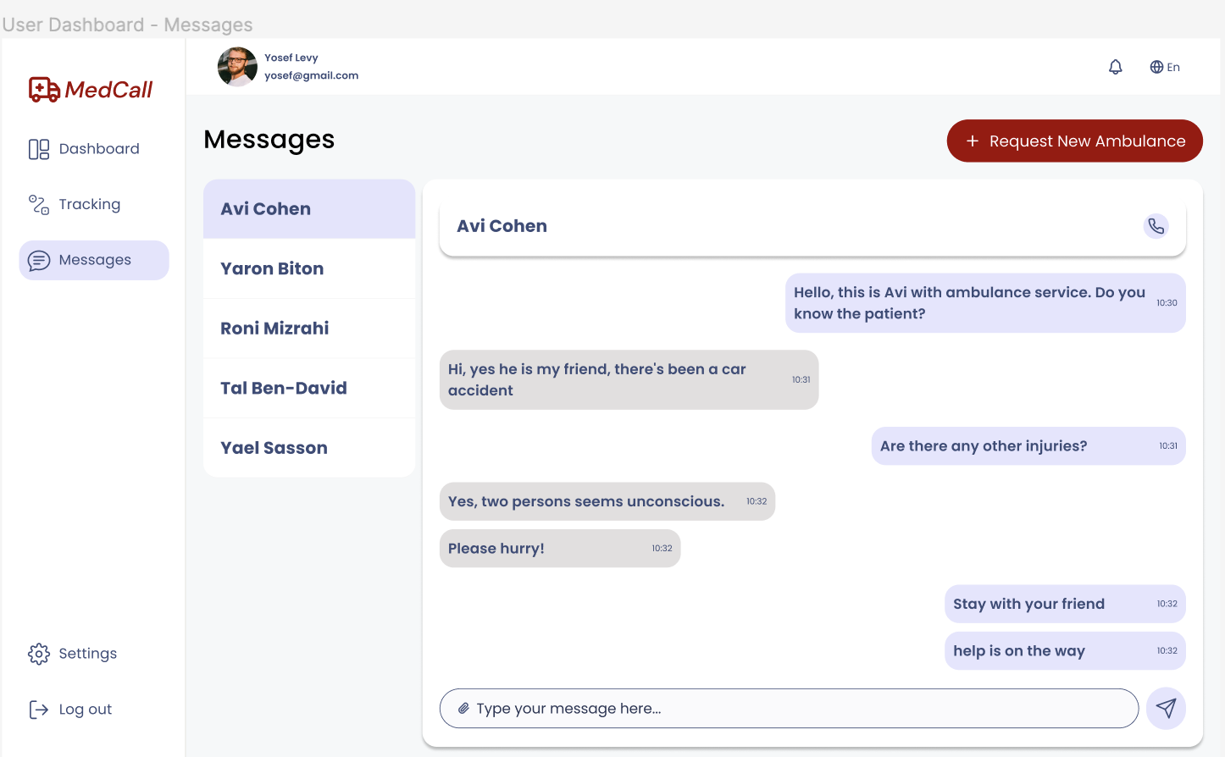

Figure 17 - User Messages

The message screen serves as a communication hub between users and drivers. Users can view and send messages related to their emergency. Additionally, users can access their previous messages.

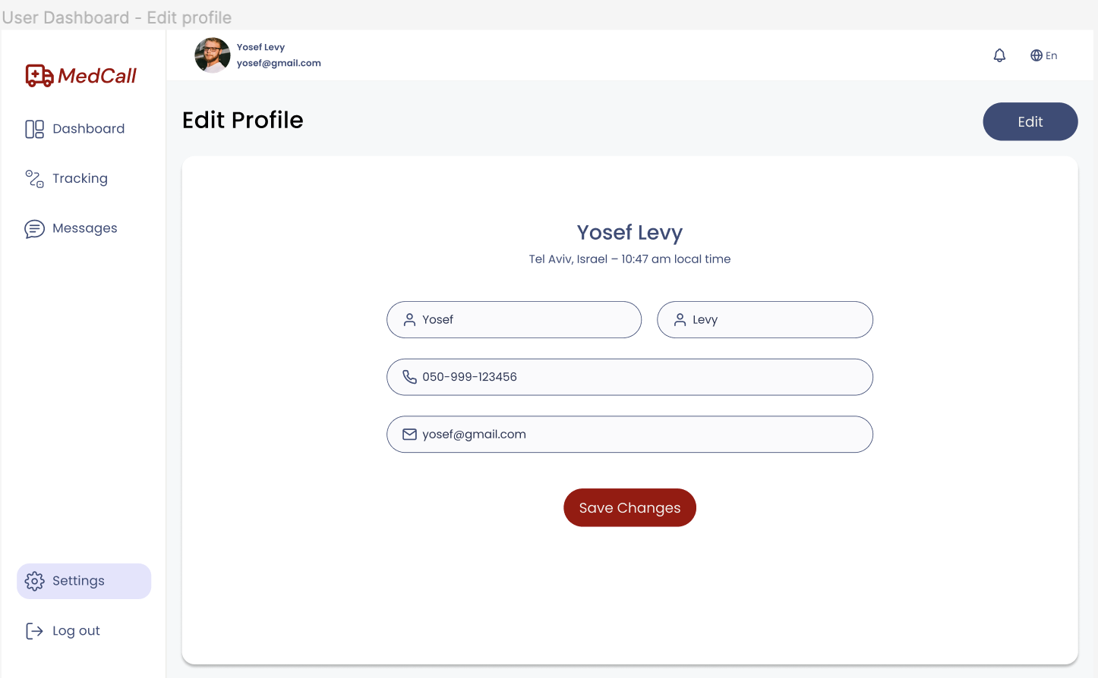

Figure 18 - Setting Screen (Edit Profile)

The settings screen allows users to edit their profile information. By pressing edit, making changes becomes available. When they finish, they should press “Save Changes”.

### *5.4.4 Driver Dashboard*

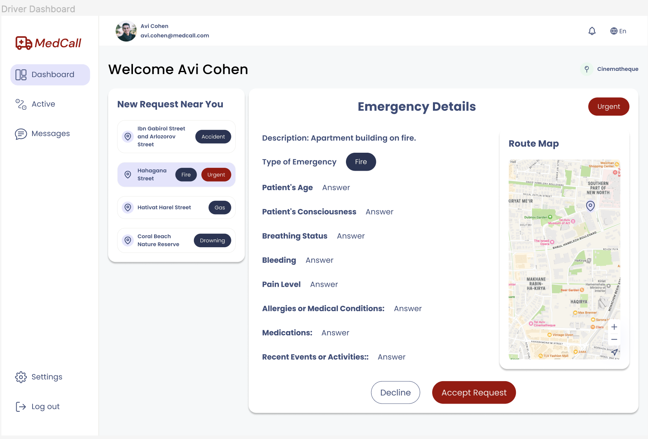

Figure 19 - Driver Dashboard

The driver dashboard displays incoming emergency requests. Drivers can see a list of new requests and view details like the type of emergency and location. Clicking on a request shows more information, including the patient's condition. The driver can choose whether to accept or decline the request. This setup helps drivers quickly assess and respond to emergencies, ensuring efficient service delivery.

The driver dashboard has a sidebar menu that allows navigating through the dashboard, view active requests and messages.

At the top users can view notifications to stay informed about important updates, and to change the language of the platform.

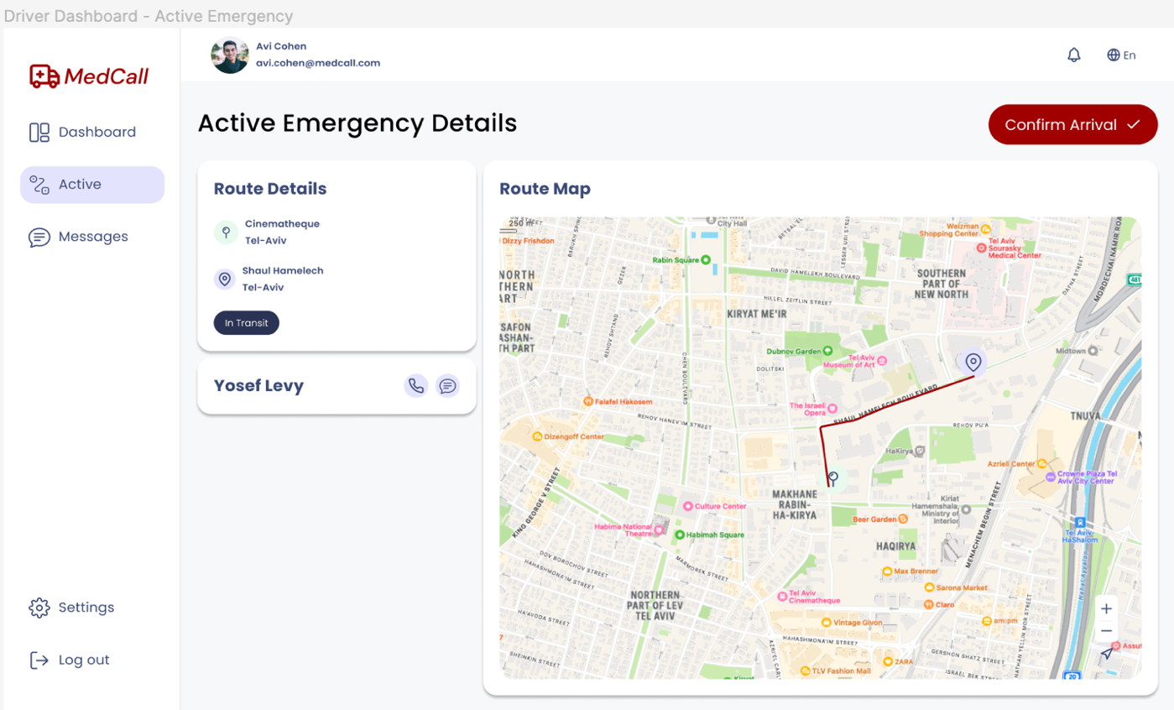The active emergency screen allows users to monitor the real-time location of the ambulance and the patient. The route and patient’s details are shown.

Figure 20 - Driver Active Request

There is a confirm arrival button that the driver can press when they arrive at the location.

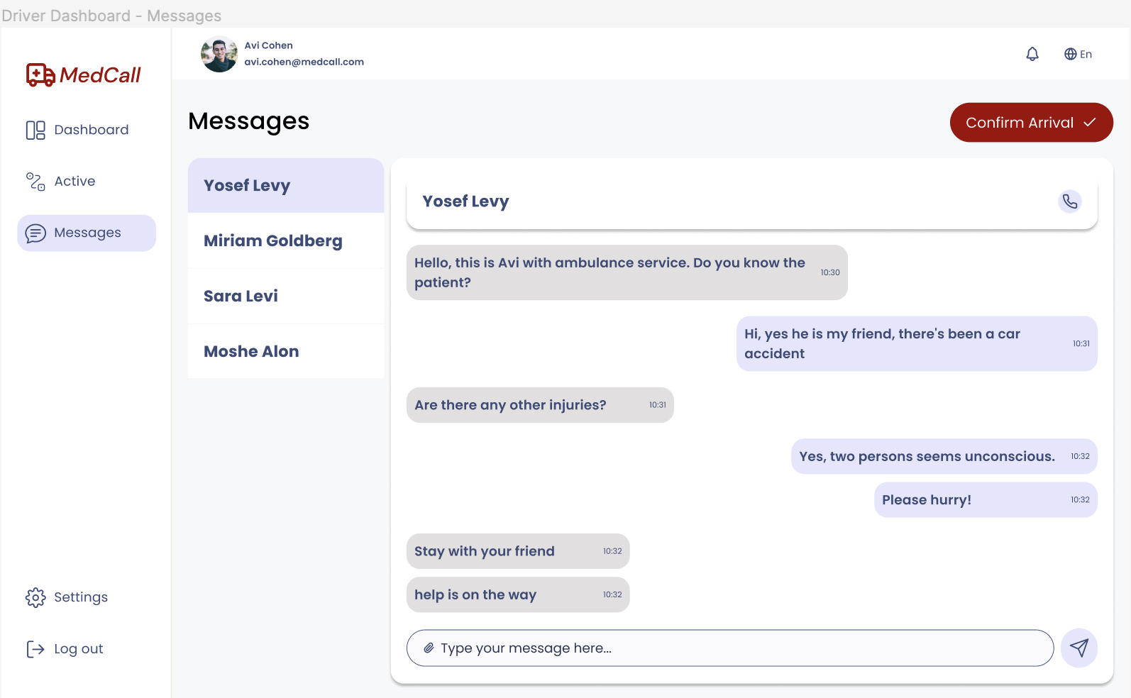

Figure 21 - Driver Messages

The message screen allows communication between the drivers and users. Drivers can view and send messages to the patients. Also, drivers can see their previous messages history.

### *5.4.5 Dispatch Center Dashboard*

Figure 22- Dispatch Center Dashboard

The dispatch center dashboard screen provides a comprehensive overview of ambulance locations and incoming emergency requests. The dashboard has a sidebar menu that allows the dispatch worker to navigate through the dashboard, view new drivers request to become users and edit existing drivers.

A map interface displays the real-time locations of ambulances, clicking on an ambulance displays a popup with detailed information about the vehicle and its status. Additionally, a list of new ambulance requests is presented, showing details such as the type of emergency and location.

Dispatchers can quickly assess the situation and assign the nearest available ambulance to each request.

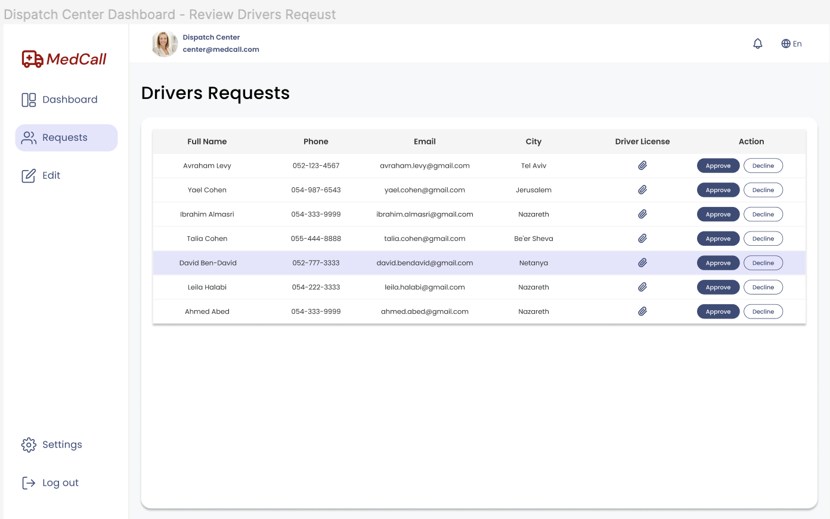

Figure 23 - Review Drivers Requests

The driver requests review screen includes a table that displays the driver’s applicant details including full name, phone, email, city, and license file. Dispatch center staff can quickly assess and decide to accept or decline driver applications, ensuring efficient approval processes.

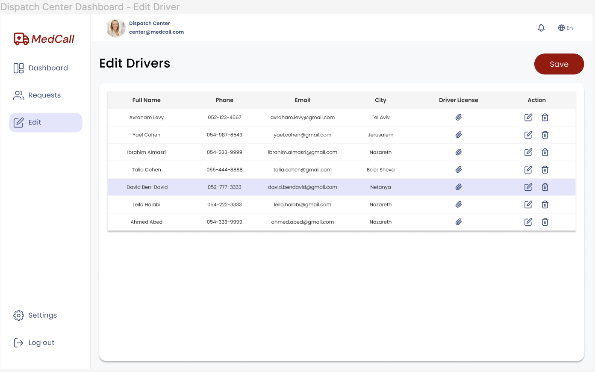

Figure 24 - Edit Drivers

The edit drivers screen includes a table that displays the driver’s details including full name, phone, email, city, and license file. Dispatch center staff can quickly assess, edit, or delete drivers.

# **Verification and Evaluation**

## ***5.1 Evaluation***

Our evaluation process will focus on assessing the MedCall platform's ability to efficiently locate the nearest ambulance, initiate emergency calls promptly, and ensure effective communication between users and ambulance drivers.

We will conduct usability testing to evaluate user-friendliness and stakeholder satisfaction through surveys. Compliance with regulatory standards governing emergency medical services, data privacy, and security measures will also be evaluated. This comprehensive evaluation aims to validate the platform's effectiveness in addressing user needs and concerns.

## ***5.2 Verification***

|  |  |  |  |
| --- | --- | --- | --- |
|  | ***Test N.*** | ***Test Description*** | ***Expected Result*** |
| ***Registration*** | 1 | Attempt to register a new user with valid input data | The user registration should be successful, and the user should receive a confirmation message indicating successful registration. |
| 2 | Attempt to register a new user with and empty input | The registration process should fail, and the user should receive an error message “Please fill in all the fields.” |
| 3 | Attempt to register a new user with an invalid email format (e.g. missing ”@”) | The registration process should fail, and the user should receive an error message “Please enter a valid email.” |
| 4 | Attempt to register a new user with a weak password | The registration process should fail, and the user should receive an error message “Password must be at least 8 characters with uppercase, lowercase, and number.” |
| 5 | Attempt to register a new user with an email address that is already registered in the system. | The registration process should fail, and the user should receive an error message “Email already in use. Please choose another.” |
| ***Login*** | 6 | Attempt to log in with valid credentials | The login process should be successful, and the user should be redirected to their account dashboard. |
| 7 | Attempt to log in with an empty input | The login process should fail, and the user should receive an error message “Please fill in all the fields.” |
| ***Login*** | 8 | Attempt to log in with an invalid credentials | The login process should fail, and the user should receive an error message “Email or password is wrong. Please try again!” |
| 9 | Attempt to log in with an email address that is not registered in the system. | The login process should fail, and the user should receive an error message “Email not found. Please signup first.” |
| ***New Ambulance Request*** | 10 | Attempt to request a new ambulance with valid information. | The request should be successfully submitted, and the nearest available ambulance should be dispatched to the specified location. |
| 11 | Attempt to request a new ambulance without providing a location. | The request should fail, and the user should receive an error message “Must enter a location.” |
| 12 | Attempt to accept an ambulance request without providing all necessary information. | The request should fail, and the user should receive an error message “Please fill in all the fields.” |
| 13 | Verify that the user receives a confirmation message after successfully requesting a new ambulance. | The user should receive a confirmation message confirming that their request has been received. |
| 14 | Verify that the user can track the real-time location of the dispatched ambulance. | The user should be able to track the ambulance's location in real-time on the platform's map interface. |
| 15 | Test the communication channels between the user and emergency services during the ambulance request process. | The user should be able to communicate with emergency dispatchers through chat to provide additional information or updates during the emergency. |
| ***Accept/Decline/Edit Drivers*** | 16 | Attempt to accept a driver request with valid information. | The request should be successfully accepted, and the driver should receive a confirmation message. |
| 17 | Attempt to accept a driver request with an invalid information | The acceptance process should fail, and the driver should receive an error message "Invalid request. Please provide all necessary information." |
| 18 | Attempt to decline a driver request with valid information. | The request should be successfully declined, and the driver should receive a confirmation message. |
| 19 | Attempt to edit driver information with valid input data. | The driver information should be successfully updated, and the driver should receive a confirmation message. |
| 20 | Attempt to edit driver information with missing necessary information. | The update process should fail, and the dispatch center should receive an error message "Please fill in all the required fields." |
| ***Accept/Decline Request*** | 21 | Driver accepts an ambulance request nearby with valid information. | The driver should successfully accept the request, and the caller and dispatch center should receive confirmation. |
| 22 | Driver declines an ambulance request nearby. | The driver should successfully decline the request, and the dispatch center should receive confirmation. |
| 23 | Driver attempts to accept an invalid ambulance request nearby | The acceptance process should fail, and the driver should receive an error message "Invalid request." |

# **References**

1. Emergency Medical Services (EMS):  
   Kobusingye, O. C., Hyder, A. A., Bishai, D., Joshipura, M., Hicks, E. R., & Mock, C. (2006). Emergency medical services. *Disease Control Priorities in Developing Countries. 2nd edition*.  
   <https://www.ncbi.nlm.nih.gov/books/NBK11744/>
2. Nearest Neighbor Algorithm:  
   Taunk, K., De, S., Verma, S., & Swetapadma, A. (2019, May). A brief review of nearest neighbor algorithm for learning and classification. In 2019 international conference on intelligent computing and control systems (ICCS) (pp. 1255-1260). IEEE.
3. Real-time Algorithm:  
   Ramamritham, K., Stankovic, J. A., & Shiah, P. F. (1990). Efficient scheduling algorithms for real-time multiprocessor systems. IEEE Transactions on Parallel and Distributed systems, 1(2), 184-194.
4. Geolocation Algorithm:  
   Djuknic, G. M., & Richton, R. E. (2001). Geolocation and assisted GPS. Computer, 34(2), 123-125.
5. Live chat services and chatbots:  
   <https://www.touchpoint.com/blog/live-chat-support/>